A000-Am,C-Taino-Tripointer-Anthropomorphic Head-Serpentine-1000 CE

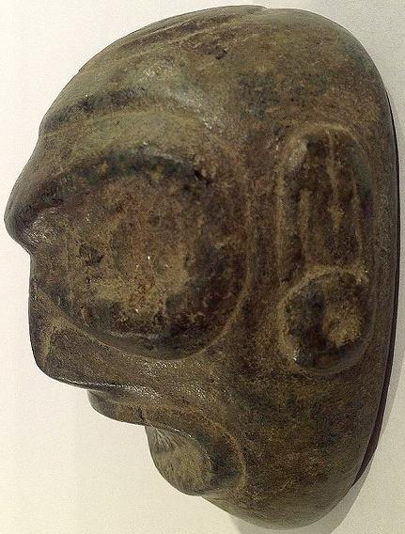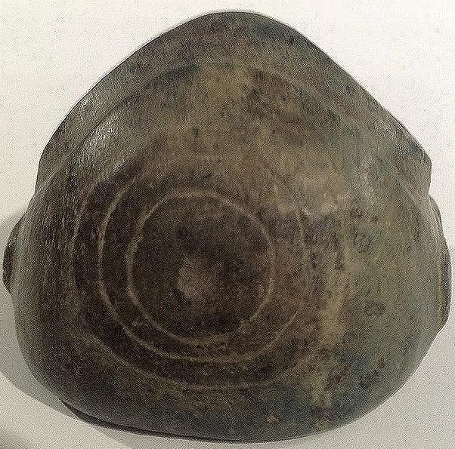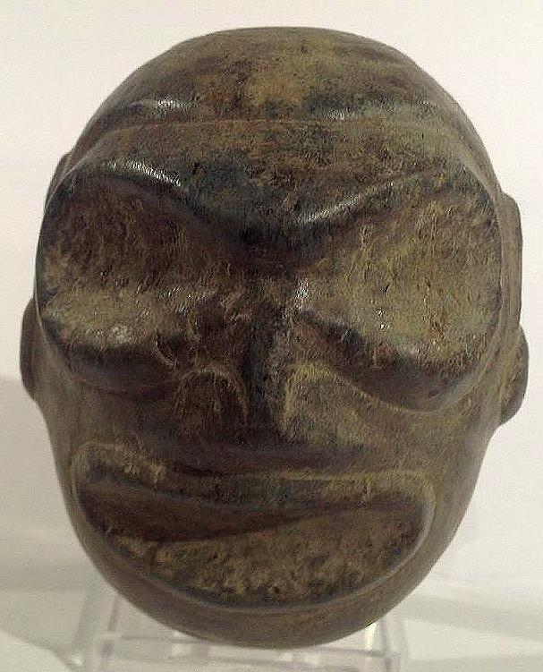

Am,C-Taino-Tripointer-Anthropomorphic Head-Serpentine-1000 CE

**Case No.: 17**

**Accession No.**

**Formal Label:**

**Display Description:**

Anthropomorphic Head, Fewkes type 3, has goggle eyes and outlined lips and wears ear spools below an intricately carved, tripartite ear. The concentric circle on the top of its head symbolizes the sun and life's energy.

These stone heads may have originated from the practice of maintaining ossuaries of important caciques or shamans, since ancestor worship was a central aspect of Taino spirituality. In ceremonial practice these objects were the conduits to the spirit world and, as such, were consulted on issues of importance to the decision-making of prominent leaders. Features of these sculptures included head bands that may have indicated symbolic elements denoting a particular cacique or group, ear elements that often included a round ear spool below the ear itself, the shape of the chin in various degrees of sharpness, and the shape of the mouth, whether it be open as if in pronouncing an utterance or closed showing only dentition, suggesting a deceased ancestor’s skull.

Jesse Walter Fewkes suggested three types of these anthropomorphic heads. The first is with an elongated base. The second type according to Fewkes is ovate with a flat base. The third type is a head without an extended base.

**LC Classification:**

**Date or Time Horizon:**

**Geographical Area:** Originally from the Dominican Republic

**Map:**

**GPS coordinates:**

**Cultural Affiliation:**

**Media:**

**Dimensions:** Length 7.5 cm or 2.9 in.

**Weight:**

**Condition:**

**Provenance:** Originally from the Dominican Republic

**Discussion:**

**References:**